**MASTERS DOCUMENTATION**

|  |  |
| --- | --- |
| **Application :** | NGERP |
| **Workflow :** | MASTERS |
| **Workflow Item Name :** | Tax Rate |

**Description :**

Tax Rate Master is used the calculate the tax rate and itdefines the GL accounts each tax rate should be posted.

**Workflow Process :**

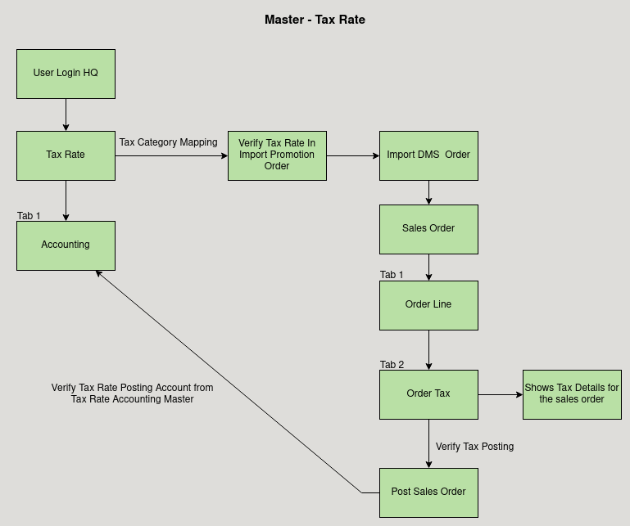

**Business Rules :**

* Tax Rate can be only added in HQ.
* The tax rate is set in the rate field.
* Accountig Tab is used to map the GL Account.
* For example when importing a Promotion order from DMS with the tax rate.
* It checks the tax rate from the tax master and calculate the tax amount for the promotion order.
* After posting the tax amount will be posted in the accounts defined in the Tax Rate Accounting Master.